Force and Motion: Friction

What Is Friction?
Friction is a force that opposes motion between two surfaces that are touching. Friction can work for or against us. For example, putting sand on an icy sidewalk increases friction so you are less likely to slip. On the other hand, too much friction between moving parts in a car engine can cause the parts to wear out.

Why Friction Occurs
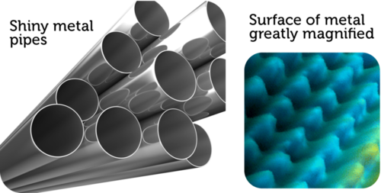
Friction occurs because no surface is perfectly smooth. Even surfaces that look smooth to the unaided eye appear rough or bumpy when viewed under a microscope. Look at the metal surfaces in Figure to the right. The metal pipes are so smooth that they are shiny. However, when highly magnified, the surface of metal appears to be very bumpy. All those mountains and valleys catch and grab the mountains and valleys of any other surface that contacts the metal. This creates friction.

Factors that Affect Friction
Rougher surfaces have more friction between them than smoother surfaces. That’s why we put sand on icy sidewalks and roads. Increasing the area of surfaces that are touching also increases the friction between them. That’s why you can’t slide as far across ice with shoes as you can with skates. The greater surface area of shoes causes more friction and slows you down. Heavier objects also have more friction because they press together with greater force. Did you ever try to push boxes or furniture across the floor? It’s harder to overcome friction between heavier objects and the floor than it is between lighter objects and the floor.

Friction Produces Heat
You know that friction produces heat. That’s why rubbing your hands together makes them warmer. But do you know why the rubbing produces heat? Friction causes the molecules on rubbing surfaces to move faster, so they have more heat energy. Heat from friction can be useful. It not only warms your hands. It also lets you light a match. On the other hand, heat from friction can be a problem inside a car engine. It can cause the car to overheat. To reduce friction, oil is added to the engine. Oil coats the surfaces of moving parts and makes them slippery so there is less friction.

Types of Friction
There are different ways you could move heavy boxes. You could pick them up and carry them. You could slide them across the floor. Or you could put them on a dolly and roll them across the floor. This example illustrates three types of friction: static friction, sliding friction, and rolling friction. Another type of friction is fluid friction. All four types of friction are described below. In each type, friction works opposite the direction of the force applied to a move an object.

Static Friction
Static friction acts on objects when they are resting on a surface. For example, if you are walking on a sidewalk, there is static friction between your shoes and the concrete each time you put down your foot. Without this static friction, your feet would slip out from under you, making it difficult to walk. Static friction also allows you to sit in a chair without sliding to the floor. Can you think of other examples of static friction?

Sliding Friction
Sliding friction is friction that acts on objects when they are sliding over a surface. Sliding friction is weaker than static friction. That’s why it’s easier to slide a piece of furniture over the floor after you start it moving than it is to get it moving in the first place. Sliding friction can be useful. For example, you use sliding friction when you write with a pencil and when you put on your bike’s brakes.

Rolling Friction
Rolling friction is friction that acts on objects when they are rolling over a surface. Rolling friction is much weaker than sliding friction or static friction. This explains why it is much easier to move boxes on a wheeled dolly than by carrying or sliding them. It also explains why most forms of ground transportation use wheels, including cars, 4-wheelers, bicycles, roller skates, and skateboards. Ball bearings are another use of rolling friction. They allow parts of a wheel or other machine to roll rather than slide over one another.

Fluid Friction
Fluid friction is friction that acts on objects that are moving through a fluid. A fluid is a substance that can flow and take the shape of its container. Fluids include liquids and gases. If you’ve ever tried to push your open hand through the water in a tub or pool, then you’ve experienced fluid friction between your hand and the water. When a skydiver is falling toward Earth with a parachute, fluid friction between the parachute and the air slows the descent. Fluid pressure with the air is called air resistance. The faster or larger a moving object is, the greater is the fluid friction resisting its motion. The very large surface area of a parachute, for example, has greater air resistance than a skydiver’s body.

